Development of an Intranet
Name
Professor’ Name
Institutional Affiliation

Development of an Intranet
Introduction
An intranet is a personal website, whose accessibility is restricted to people within the company and which allows for information sharing. Creating an intranet involves developing a site and applying a hosted service (Devu & Katta, 2016). The essence of creating an intranet is to improve the ways of sharing information among the company employees and clients. It is vital to creating an intranet portal that will restrict the accessibility to the authorized persons only. In this task, there will be a system of recommending a suitable prototype for the Communifire Social Solutions (Bennett, 2014). The paper will summarize the considerations, possible recommendations and the processes that will be undertaken in launching the intranet. It will also give possible examples of how the organization is using the intranet to promote sharing of information as well as the suggestions that could be included in developing the communication models with employees.
Intranet Research and the Company of Choice
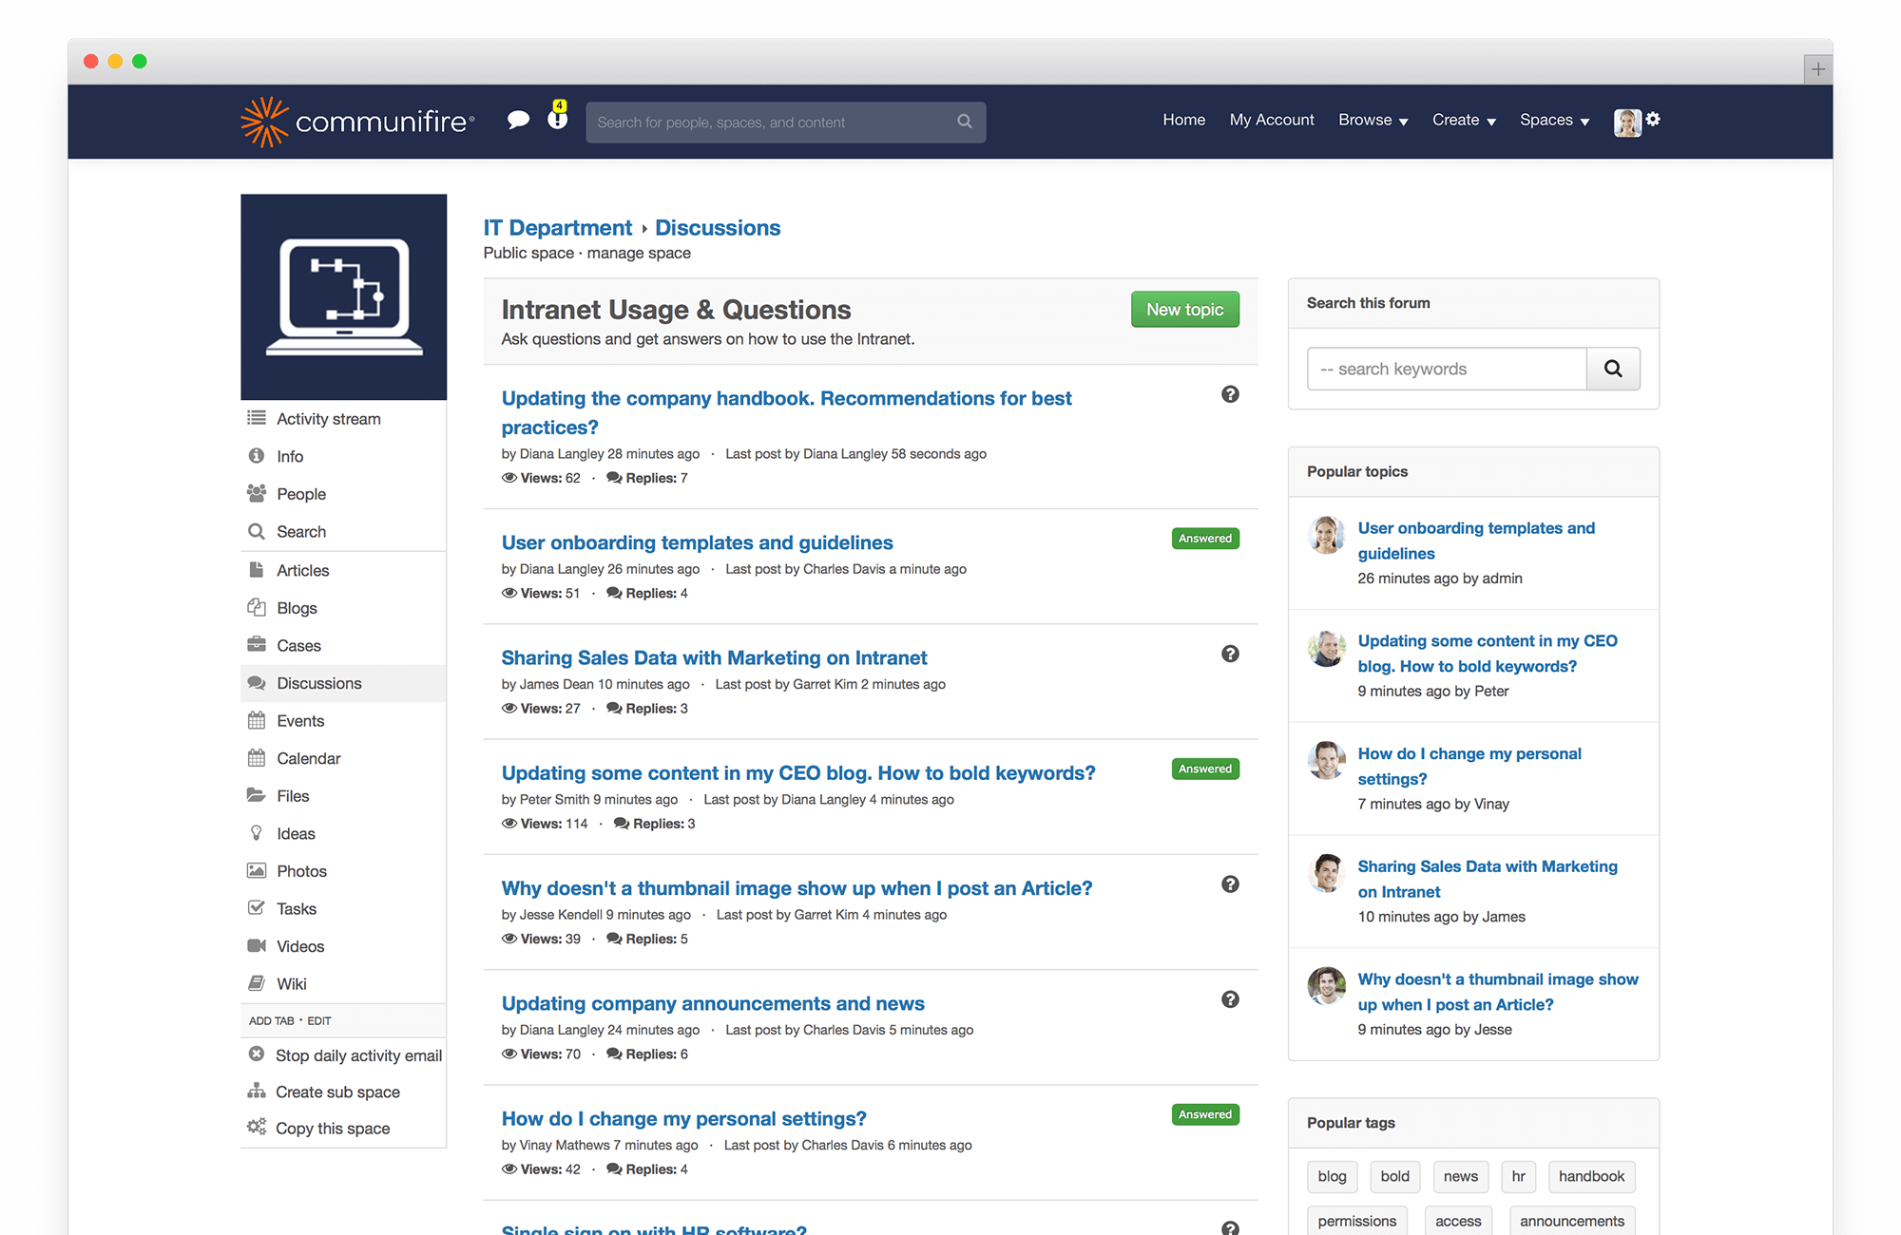

Figure 1: Sample Intranet
Many business organizations have concentrated on the adoption of the intranet as a way of improving the systems of communications among the participants (Bachmaier, 2015). With the rapid rates of adoption of the technological application, most institutions such as Communifire Social Community are facing emergent issues such as development, implementation and managing the intranets. The technological issues are related to security, the total bandwidth, the levels of scalability and interoperability (Devu & Katta, 2016). The issues related to the business include selecting choosing the most effective tools for development and how to define the strategies of outsourcing (Bennett, 2014). The other issue that the institution is facing is coming up with policies for ownership of data and development of policies for sharing of information. Given these great issues of importance, a business company must select a prototype that can address the constraints such as the increasing cybersecurity threats.
The best prototype for the intranet will be like that for the Communifire, which has considerations such as the forum and commenting capabilities, which will lead to the development of a strong threaded communication for the intranets (Bachmaier, 2015). Forums will help in the display of the specific discussions in a more organized way, which entices the users to be interactive (Bennett, 2014). The other consideration is the ideation and management of innovation capabilities. The feature of ideation makes it easier for the users to share ideas. The intranet should also be made with the functionality of discovering information and smart search. The feature of smart search will help in navigation when the organization grows in size and scope.
Recommendations and tips to be followed
There are possible recommendations that will be undertaken to ensure that the intranet is effective as a platform for information sharing among users. Firstly, the feature of the streamed user interface will be valuable in improving its performance (Devu & Katta, 2016). Just like the intranet for the Communifire, the user interface will have features such as the buttons and the drop-down menu to allow for navigation. The other tip is the development of a clean and minimalist design in nature, which can enable the users to have a dramatic experience.
The design looks at the visual look of the intranet, where a well-organized and minimalized design will make it easy for users to navigate the menu. The other feature to consider when launching the intranet will be the compatibility (Bennett, 2014). It is evident that in launching the intranet, the company will look out for a solution that will fit the current information technology setup. Such a solution will allow the intranet to be used by all the desired businesses regardless of the IT infrastructure.
The intranet will also be developed with the document sharing capabilities (Bennett, 2014). The protocol should not only be limited to the intangibles, where the platform will allow the users to share documents freely. Document sharing allows the employees to send and retrieve large documents such as financial records. The protocol will also allow for mobile functionality (Devu & Katta, 2016). This implies that the intranet will be developed with the capabilities of accessing information of the organization from mobile devices.
A mobile intranet will allow employees to share organizational information on their smartphones and tablets, which will reduce the constraint of restricted accessibility. Moreover, the platform will be linked to platforms such as social media and emails (Devu & Katta, 2016). It is evident that the intranet will allow for the inclusivity of all social media users, where linking it to the social networks will improve the traffic needed for growth (Bennett, 2014). Linking it to social platforms will also be a communication strategy for the products and services within the company.
Conclusion
It is evident that the nature of the prototype will determine the functionality of the intranet. From the sample of the intranet, there are essential social features that can help in the development of an effective intranet. Some of these features include the forum and commenting capabilities, which allows for the neat organization of discussions. The intranet will also be made with the function of document sharing, which will enable users to upload and download huge files that contain big volumes of data. Consequently, the interface will be made with the streamlined user interface, which will allow for the ease of navigation of the menu. For instance, the drop-down menu will be useful in navigating through the items listed on the platform.

References
Devu, R. R., & Katta, S. R. (2016). Intranet Design Strategies. International Journal of Electrical and Computer Engineering, 6(3), 936.
Bennett, E. E. (2014). How an intranet provides opportunities for learning organizational culture: Implications for virtual HRD. Advances in Developing Human Resources, 16(3), 296-319.
Bachmaier, V. (2015, November). Tacit Knowledge Externalisation Over Social Intranets: Developing a Conceptual Model. In International Conference on Intellectual Capital and Knowledge Management and Organisational Learning (p. 336). Academic Conferences International Limited.

